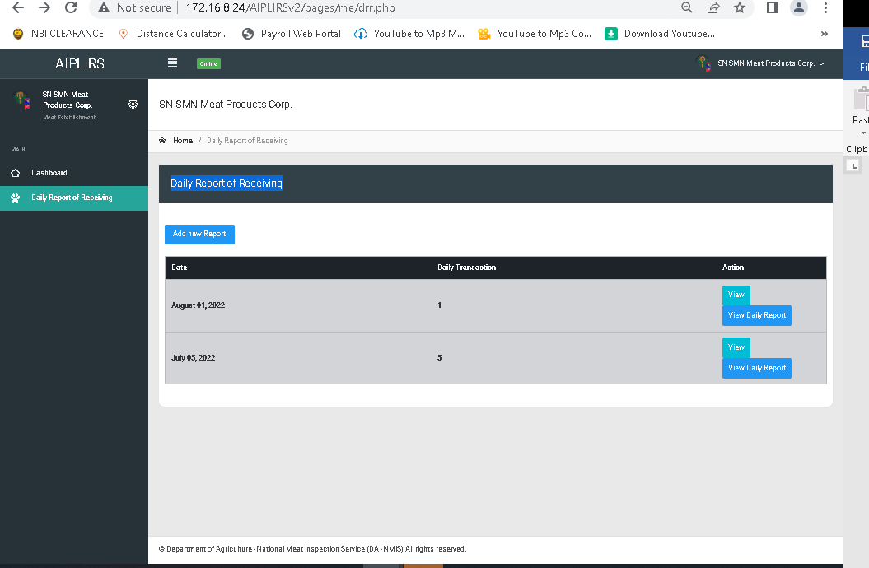

Change sidebar header and navigationbar header to “Receiving of Animals”

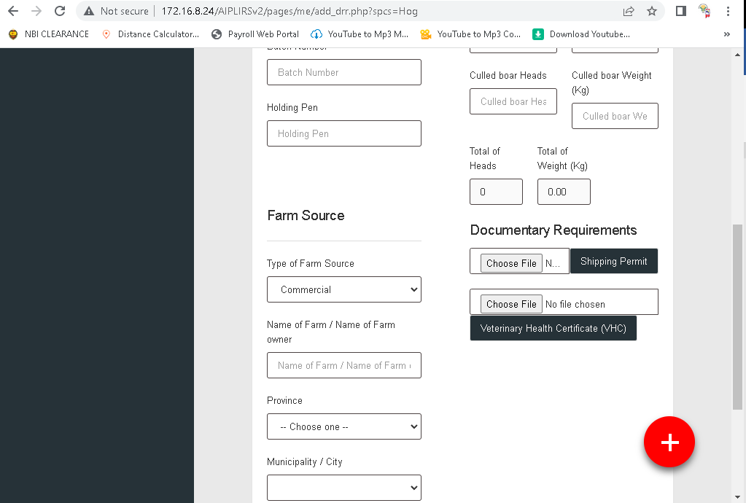

Choos file button make center reduce margin bottom

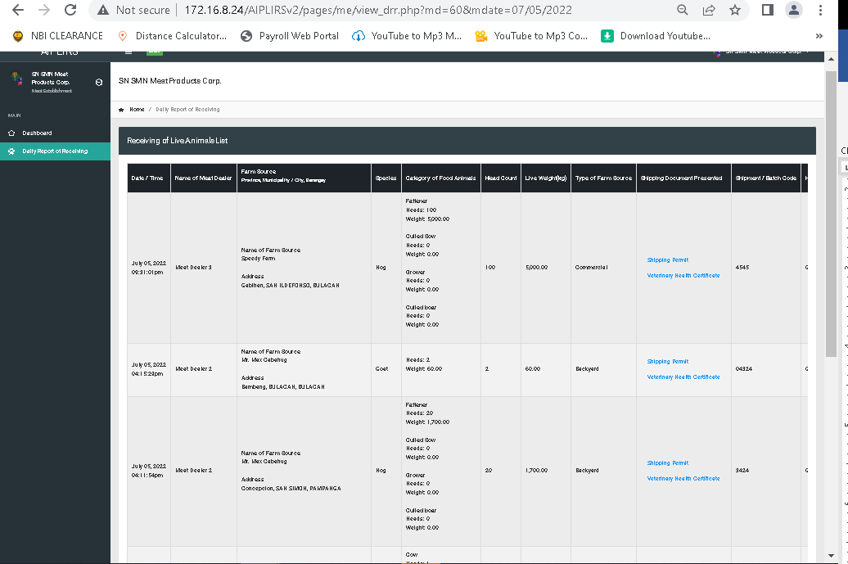

Same pattern in MIO “Daily receiving of animals” important details: drr status , Inspection status

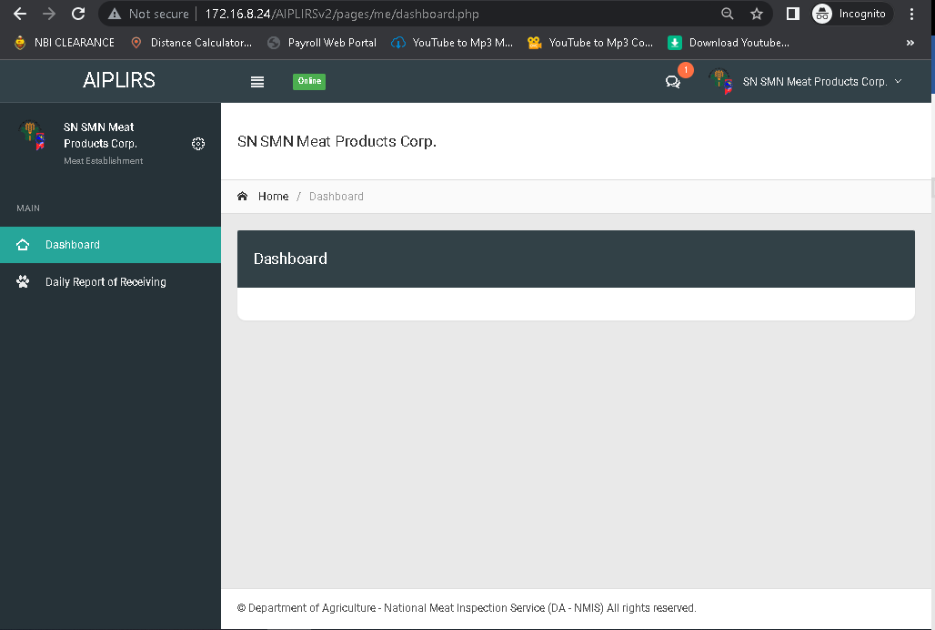

Summary for the receiving, Fit for Slaughter, Fit for human Consumption

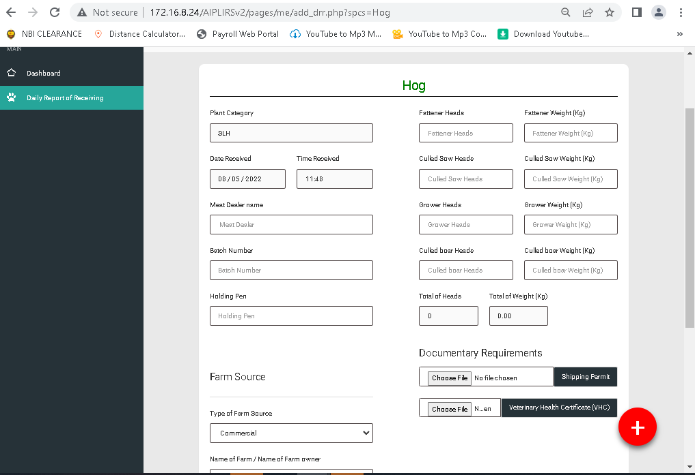

Plus sign change to “submit” add pop up alert “Are you sure you want to submit your report? “ on pop up add button “Yes” “No”

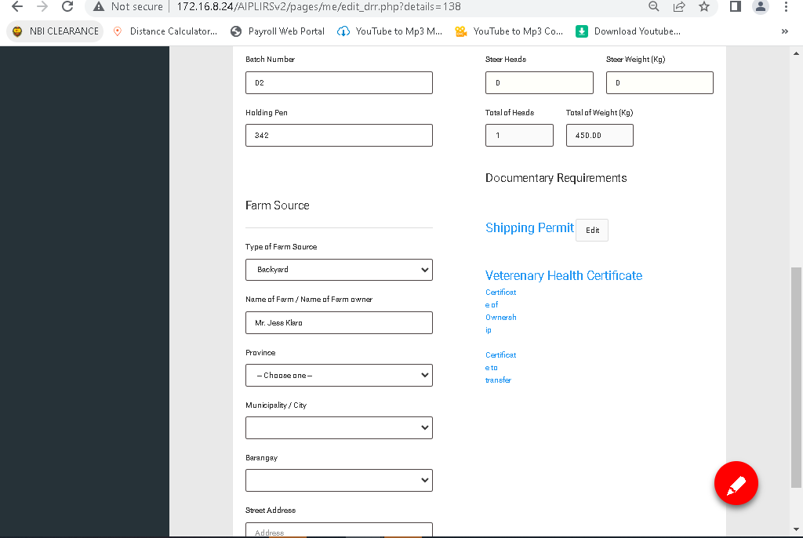

Change edit icon to word “Submit”

Spelling of Veterinary certificate

Change font of the LINK for certificate of ownership, transfer

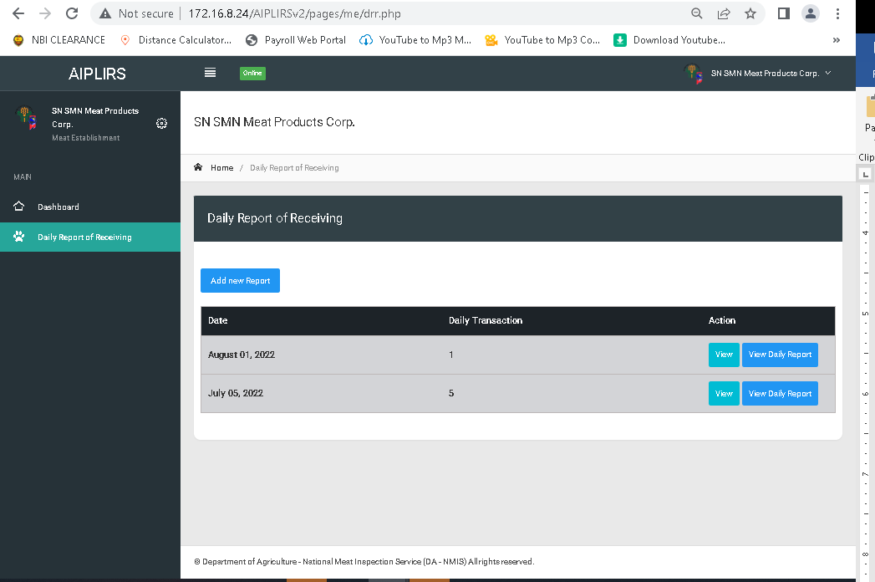

List of transaction same with sidebar

Receiving of Animals: create a ctive dropdown: add new transaction, List of transaction

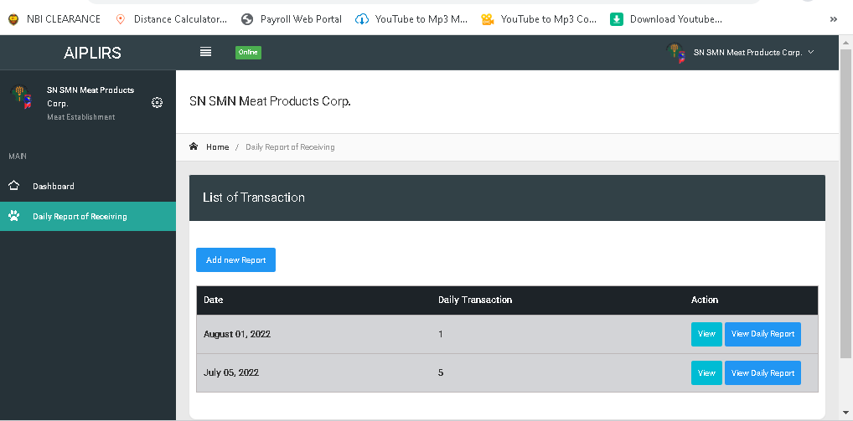

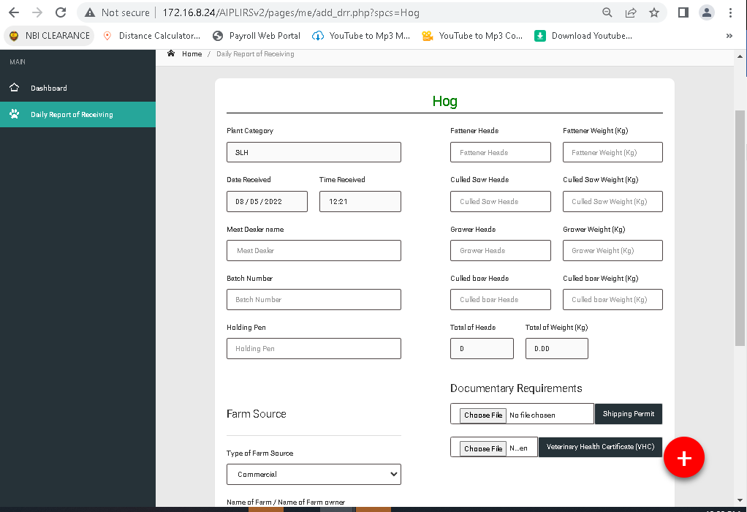

Meat Dealer name: change to Name of meat dealer on meat dealer input create a template for name standards, on registration lastname, firstname.

Batch number must be aut genaerated reset by month day batch number (format: mmdd-batch number)

Plant Category remove

Remove break line and the spacing of the farm source spacing top

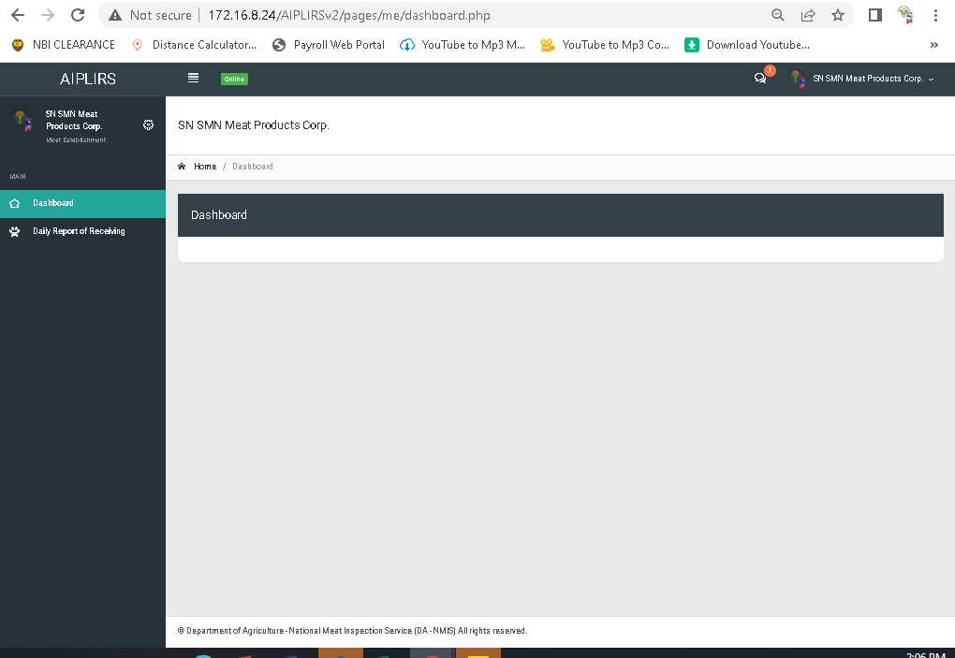

Add a summary for the me receiving,fit for slaughter, fhc

For the header of reports summary 

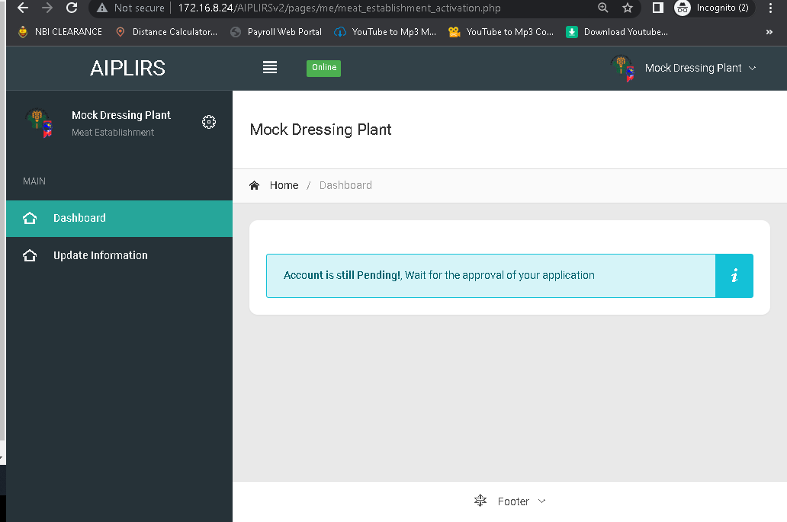

for the modal message for comment of our data privacy officer

for the button I understand and proceed add a confirmation icon

Your account is still pending.

Please wait for the approval of your account make it center

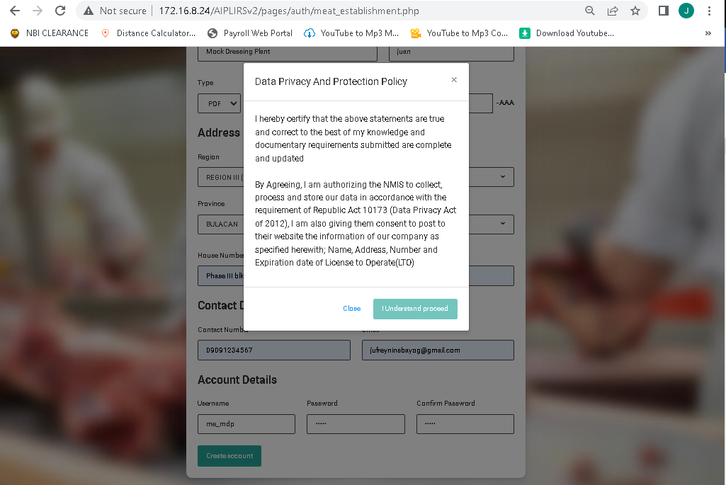

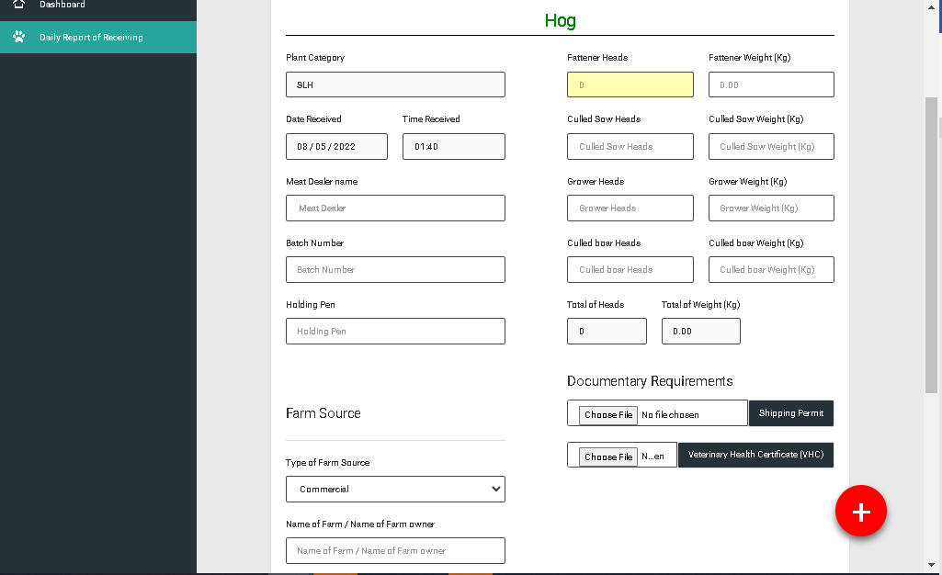

For the placeholder of the category of food animal make it 0 and holding pen

Total Heads to total head count

Total Weight to total live weight(kg)

For the label of the input of category of food animals

Heads to head count

Weight to live weight(kg)